FOR IMMEDIATE RELEASE
THE INVISIBLE THEATRE PRESS RELEASE
ProVentures, Inc.
Press Contact: Betsy Kruse Craig
Administration: (520) 884-0672
Box Office: (520) 882-9721
1400 N. First Avenue, Tucson, AZ 85719
betsy@invisibletheatre.com
www.invisibletheatre.com

The Invisible Theatre’s 55th season begins with
Sarah Ruhl’s
IN THE NEXT ROOM (OR THE VIBRATOR PLAY)
Directed by Christina Walker
INVISIBLE THEATRE OPENS ITS 55TH SEASON WITH A PLAY THAT'S PART COMEDY, PART REVELATION
Sarah Ruhl's In the Next Room (Or The Vibrator Play) runs September 13–27 at Invisible Theatre
TUCSON, AZ — Invisible Theatre launches its landmark 55th season with one of the most celebrated American comedies of the past two decades. Sarah Ruhl's In the Next Room (or the Vibrator Play), directed by Christina Walker, opens September 13 and runs through September 27 at Invisible Theatre, 1400 N. First Avenue.
The play is set at the dawn of the electrical age in late 19th-century America, where Dr. Givings operates a clinical practice out of his home. Using a newly invented, electrically powered medical device, he treats female "hysteria" by inducing what the medical establishment of the day calls therapeutic "paroxysms." In the next room, his young wife Catherine listens through the walls — growing increasingly curious, and increasingly aware of something she cannot name.
What begins as pure comedy quietly becomes something more: a luminous, poetic meditation on intimacy, technology, and what it means to truly know another person.
A Tony Award nominee and Pulitzer Prize finalist, Ruhl's play has lost none of its wit or its warmth. It remains as funny, surprising, and deeply moving as when it premiered on Broadway in 2009.
The production stars Hannah Turner as Catherine Givings, Josh Parra as Dr. Givings, and Allison Akmajian as Sabrina Daldry, alongside Sean Patrick, Kat Basso, Taylor Rascher, and Tanisha Ray. The creative team includes Todd and Silken Poelstra (Scenic Design), Maryann Trombino (Costume Design), James Blair (Lighting Design), and Rob Boone (Sound Design).
In the Next Room (or the Vibrator Play) runs September 13–27, 2026. Previews September 13 and 15. Opening Night September 16. Tickets and information at invisibletheatre.com or by calling 520-882-9721.

CAST
Dr. Givings: Josh Parra
Catherine Givings: Hannah Turner
Sabrina Daldry: Allison Akmajian
Mr. Daldry: Taylor Rascher
Elizabeth: Tanisha Ray
Annie: Kat Basso
Leo Irving: Sean Patrick

PRODUCTION STAFF
Director: Christina Walker
Producer: Betsy Kruse Craig
Stage Manager: Edith Craig
Scenic Design: Todd Poelstra, Silken Poelstra,
Costume Design: Maryann Trombino
Lighting Design: James Blair
Managing Artistic Director: Betsy Kruse Craig
Co-Managing Director: Linda Pierce

WHEN and WHERE:
THE INVISIBLE THEATRE, 1400 NORTH FIRST AVE, TUCSON AZ 85719

IN THE NEXT ROOM (9/13 - 9/27/26)
9/13 – Sun - 2:00pm
9/15 – Tue - 7:30pm
9/16 – Wed - 7:30pm
9/17 – Thur - 7:30pm
9/18 – Fri - 7:30 pm
9/19 – Sat- 2:00pm
9/20 – Sun - 2:00pm
9/23 – Wed - 7:30pm
9/24 – Thur - 7:30pm
9/25 – Fri - 7:30 pm
9/26 – Sat - 2:00pm - 7:30pm
9/27 – Sun - 2:00pm

TICKETS AVAILABLE THROUGH THE BOX OFFICE AT 520-882-9721 OR 24/7 at www.invisibletheatre.com

About the Creative Team
SARAH RUHL (PLAYWRIGHT):
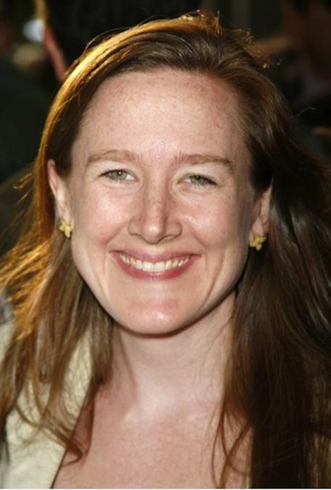
Sarah Ruhl is an award-winning American playwright, author, essayist, and professor. Her plays include The Oldest Boy, Dear Elizabeth, Stage Kiss, In the Next Room, or the vibrator play (Pulitzer Prize finalist, 2010); The Clean House (Pulitzer Prize finalist, 2005; Susan Smith Blackburn Prize, 2004); Passion Play (Pen American Award, Fourth Freedom Forum Playwriting Award from the Kennedy Center); Dead Man’s Cell Phone (Helen Hayes Award for Best New Play); Melancholy Play; Demeter in the City (nine NAACP Image Award nominations); Scenes From Court Life; How to Transcend a Happy Marriage, For Peter Pan on Her 70th Birthday; Eurydice; Orlando; and Late: a cowboy song. Her plays have been produced on Broadway and across the country as well as internationally, and translated into fourteen languages. Originally from Chicago, Ms. Ruhl received her M.F.A. from Brown University, where she studied with Paula Vogel. She is the recipient of a Helen Merrill Emerging Playwrights Award, a Whiting Writers’ Award, a PEN Center Award for mid-career playwrights, a Steinberg Distinguished Playwright Award, and a Lilly award. She is a member of 13P and New Dramatists and won the MacArthur Fellowship in 2006. She teaches at Yale School of Drama and lives in Brooklyn with her family. (Official Headshot by Greg Constanzo)
CHRISTINA WALKER (DIRECTOR)
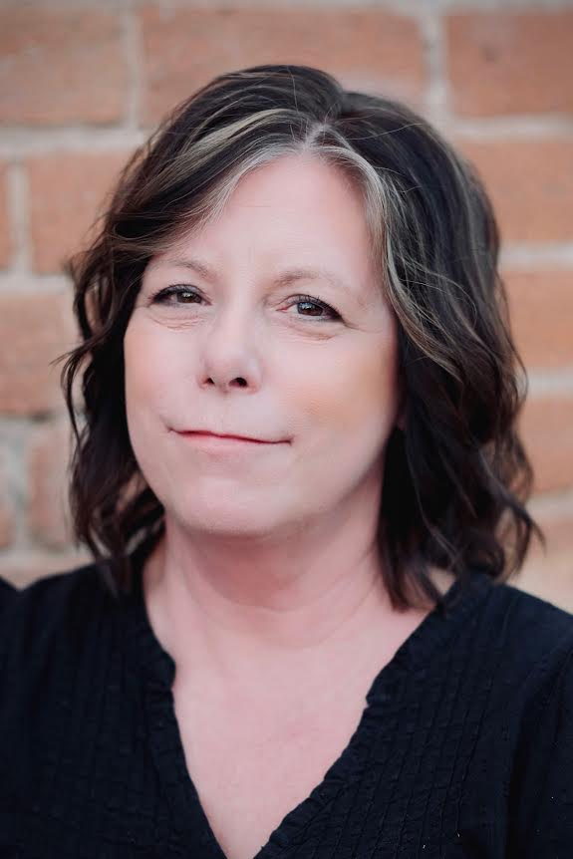
CHRISTINA WALKER (director):is thrilled to be working with Invisible Theatre for the first time! While she may be new to Invisible Theatre, Christina is no stranger to the Tucson theatre community. After earning her degree from the University of Washington, she taught acting, voice & movement, and theatre history at Pima Community College for more than 12 years, while also spending 17 years acting, directing, and working behind the scenes with theatres in Tucson and Seattle. Most recently, she directed Silent Sky at Live Theatre Workshop. She has also directed A Tucson Pastorela at Borderlands Theater three times and Tucson’s first production of The Vagina Monologues, which played to a rowdy, sold-out house at the Rialto Theatre. Favorite acting roles include Helena in A Midsummer Night’s Dream with Shakespeare Under the Stars and PCC, Boo in Blue Window at MetaTheater, and Hazel in Rooted at Live Theatre Workshop. Christina has been fortunate to work with many wonderful Tucson theatre companies over the years, (including aka Theater, MetaTheater, Quintessential Productions, and Damesrocket Theater) many of which, sadly, are no longer around! After taking some time away from theatre to raise her amazing daughter, Christina is delighted to be back and grateful to be making theatre again. Thank you for supporting live theatre and the arts in Tucson!

THE INVISIBLE THEATRE:
The Invisible Theatre of Tucson, a non-profit 501(c)3 organization, is dedicated to producing quality theatre and arts education experiences for all facets of the community, in an intimate setting that showcases local professional talent and guest artists. Started in 1971 as an arena for local playwrights, the theatre has expanded its programs to include adaptations of classics and recent Off- Broadway plays and musicals, while continuing to encourage new playwrights through both full productions and stage readings. Through our commitment to building empathy through artistic excellence, Invisible Theatre produces plays and theatrical events that invite community connections, ignite dialogue, and bring visibility to the stories that unite us all.
Tickets are also available 24/7 through AudienceView at www.invisibletheatre.com.
Visa, MasterCard, Discover and American Express are accepted.
Sarah Ruhl's In the Next Room (or the Vibrator Play) runs September 13–27 at Invisible Theatre

