FOR IMMEDIATE RELEASE
INVISIBLE THEATRE PRESS RELEASE
ProVentures, Inc.
Press Contact: Betsy Kruse Craig
Administration: (520) 884-0672
Box Office: (520) 882-9721
1400 N. First Avenue, Tucson, AZ 85719
betsy@invisibletheatre.com
www.invisibletheatre.com

The Invisible Theatre Continues IT’s 54th Season with
ENCORE PERFORMANCE OF
WHAT THE CONSTITUTION MEANS TO ME
By
Heidi Schreck
Directed by Carrie Cole

The Invisible Theatre is bringing back WHAT THE CONSTITUTION MEANS TO ME which played to sold out houses for four weeks this January. This award-winning, boundary-breaking play breathes new life into our Constitution and imagines how it will shape the next generation of Americans. Fifteen-year-old Heidi earned her college tuition by winning Constitutional debate competitions across the United States. In this hilarious, hopeful and achingly human new play, she resurrects her teenage self in order to trace the profound relationship between four generations of women and the founding document that shaped their lives.
Betsy Kruse Craig, Invisible Theatre’s Managing Artistic Director, is featured as Heidi. The cast also includes David Alexander Johnston and Ash Martin.

Schreck’s timely and galvanizing play became a sensation off-Broadway before transferring to Broadway where it received two Tony Award nominations among countless other accolades. The New York Times hailed “What the Constitution Means to Me” as “not just the best play to open on Broadway so far this season, but also the most important.”

ALL TICKETS $35: STUDENT DISCOUNTS ARE AVAILABLE

“Endearingly funny and deeply affecting. It would be hard to identify a work for the theater with its finger more on the pulse of America right now.” – Peter Marks, The Washington Post

www.invisibletheatre.com for online tickets.

CAST
Betsy Kruse Craig
Ash Martin
David Alexander Johnston

PERFORMANCE DATES
Thursday, December 4th, 2025 7:30pm
Friday, December 5th, 2025 7:30pm
Saturday, December 6th, 2025 2:00pm
Sunday, December 7th, 2025 2:00pm

PRODUCTION STAFF
DIRECTOR: Carrie Cole
PRODUCER: Betsy Kruse Craig
TECHNICAL DIRECTION: James Blair
COSTUME DESIGNER: Maryann Trombino
PRODUCTION STAGE MANAGER: Linda Pierce
WHERE:
The Invisible Theatre 1400 N. First Avenue (at Drachman), Tucson, AZ 85719
RUNNING TIME:
90 minutes with no intermission
AGE RECOMMENDATION: High School PG

ABOUT THE PLAYWRIGHT
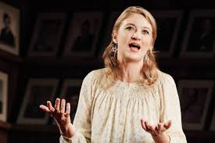

Heidi Schreck is a writer and performer living in Brooklyn. Her critically acclaimed play What the Constitution Means to Me played an extended, sold-out run on Broadway in 2019, and was nominated for two Tony Awards. It had subsequent runs at the Kennedy Center in Washington D.C., the Mark Taper Forum, The Guthrie, Seattle Repertory Theatre, and at theaters all over the country. A filmed version of the play premiered on Amazon Prime Video, and was nominated for a Critics Choice Award, a PGA Award and DGA Award. What the Constitution Means to Me was named Best of the Year by the New York Times, the Los Angeles Times, the Chicago Tribune, TimeMagazine, The Hollywood Reporter, The New Yorker and more. Schreck’s other plays Grand Concourse, Creature, and There Are No More Big Secretshave also been produced in NYC and throughout the United States. Screenwriting credits include “I Love Dick,” “Billions,” “Nurse Jackie,” “Dispatches from Elsewhere.” She is the recipient of three Obie Awards, a Drama Desk Award, and a Theatre World Award; as well as the Horton Foote Playwriting Award and the Hull-Warriner Award from the Dramatists Guild. She has also worked as a teacher and journalist in St Petersburg, Russia and has done live simultaneous translations of plays by Chekhov, Gorky, and Ostrovksy. Schreck was awarded Smithsonian Magazine’s 2019 American Ingenuity Award, for her work in the Performing Arts.

THE INVISIBLE THEATRE:
The Invisible Theatre (IT) of Tucson, a non-profit 501(c)3 organization, is dedicated to producing quality theatre and arts education experiences for all facets of the community, in an intimate setting that showcases local professional talent and guest artists. Started in 1971 as an arena for local playwrights, the theatre has expanded its programs to include adaptations of classics and recent Off- Broadway plays and musicals, while continuing to encourage new playwrights through both full productions and stage readings. Our award winning arts education program for special needs children focuses on ability rather than dwelling on disability. Our commitment to artistic excellence, diversity, equity, inclusion and quality has made the Invisible Theatre a very visible force in the local, national, and international arts scene.
Tickets are also available 24/7 through AudienceView at www.invisibletheatre.com.
Visa, MasterCard, Discover and American Express are accepted.

Solo performance is a unique experience for both the actor and the playwright. For the actor, it can be a very vulnerable experience. They take the stage alone and must For the playwright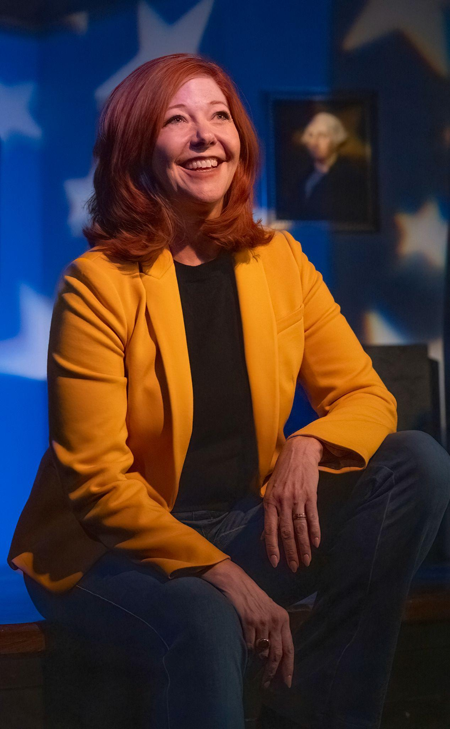, the difficulty is in creating a fully realized, rich narrative within the confines of monologue. The intent of this theatrical undertaking is to celebrate the complex relation the actors and writers face when creating solo works. Much like the art of the flying trapeze, the one who flies must have someone there to catch them.

